NIIT UNIVERSITY DISCUSSION PORTAL

TESTING

BLACKBOX TESTING

**Login Page**:

**Positive Scenario**

**Inputs**: Valid Username and Password

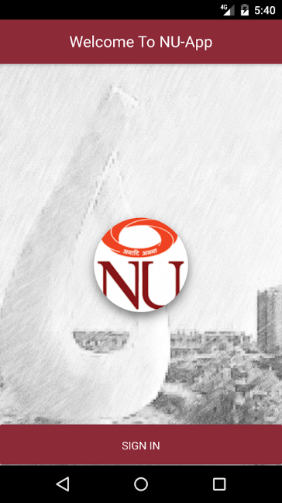

**Desired Outputs**: Redirected to Timetable page.

**Actual Output**: The website redirects to the Timetable page

**Negative Scenario**: Invalid Credentials

Input: Wrong Username and Password

Desired Output:Redirected to the login page again and give message invalid input

Actual output: redirected To Login Page again

TEST CASE STATE: Succesful

**Timetable Page**:

**Positive Scenario: Time table displayed**

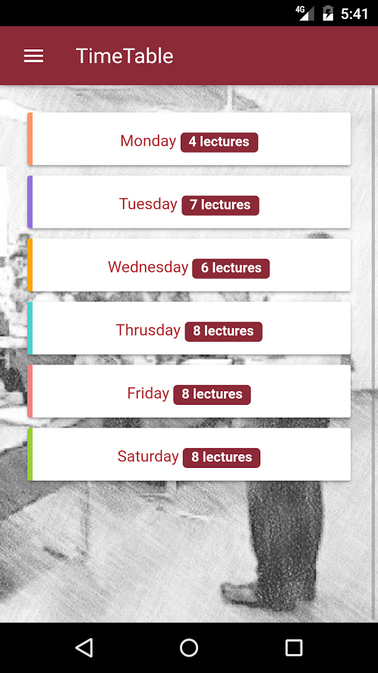 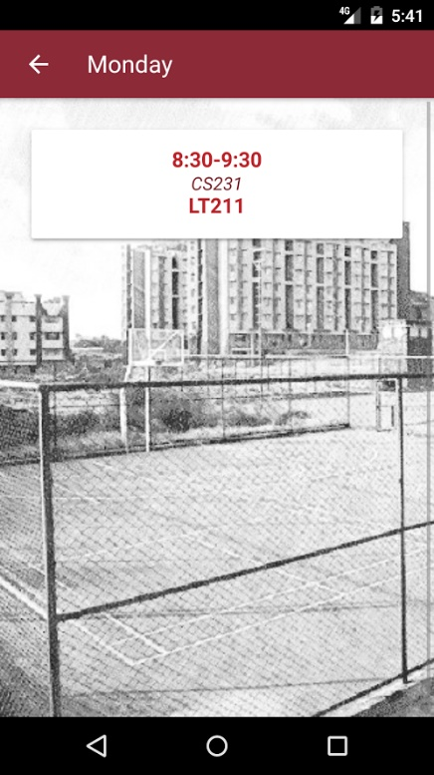

**Desired Outputs**: Redirected to Timetable slots.

**Actual Output**: Shows dummy data

**Negative Scenario**: API Failed

Desired Output: Not available

Actual output: Empty page displayed

TEST CASE STATE: Failure

**Gate pass**

**Positive Scenario: Gatepass status displayed**



**Desired Outputs**: Status of the gate pass is displayed

**Actual Output:** Status of the gate pass is displayed

**Negative Scenario**: API Failed

Desired Output: Not available displayed

Actual output: Not available displayed

TEST CASE STATE: Succesful

**GATE PASS**

**Positive Scenario**

**Inputs**: Gate pass input details.

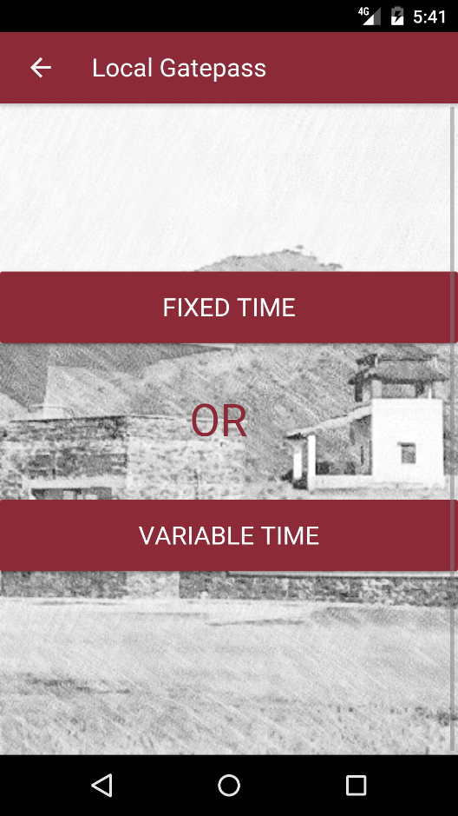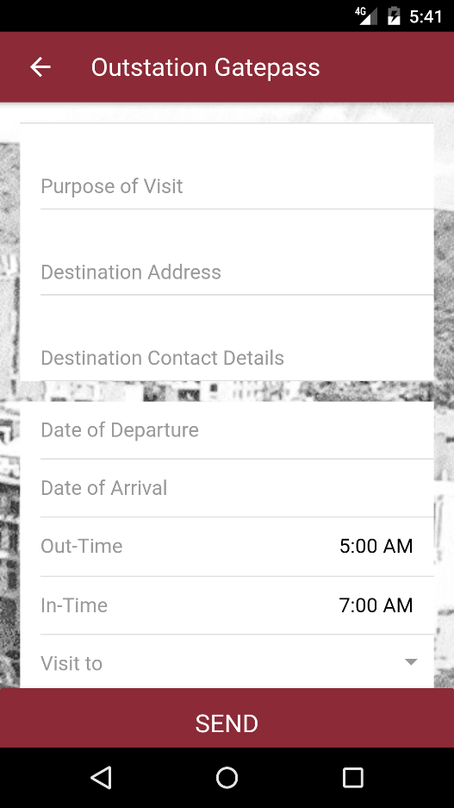

**Desired Outputs**: Gatepass applied

**Actual Output**: Gatepass applied

**Negative Scenario**: API failed

Input: Gate pass input details.

Desired Output: Not available displayed

Actual output: Not available displayed

TEST CASE STATE: Succesful

**Attendance**

**Positive Scenario**

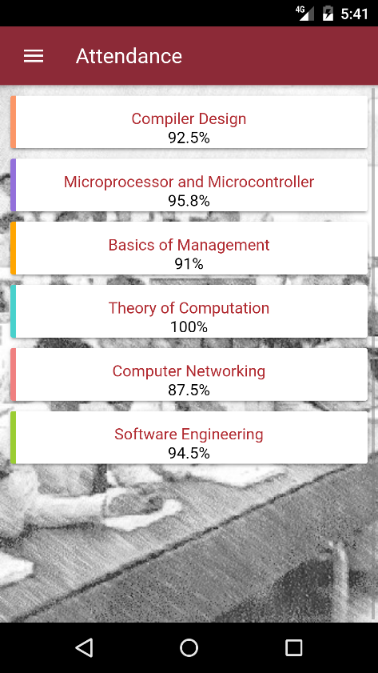

**Desired Outputs**: Attendance displayed.

**Actual Output**: Dummy data displayed

**Negative Scenario**: API Failed

Desired Output: Not Available displayed.

Actual output: Not Available displayed.

TEST CASE STATE: Failed

**Library**

**Positive Scenario**

**Input: Search for book**

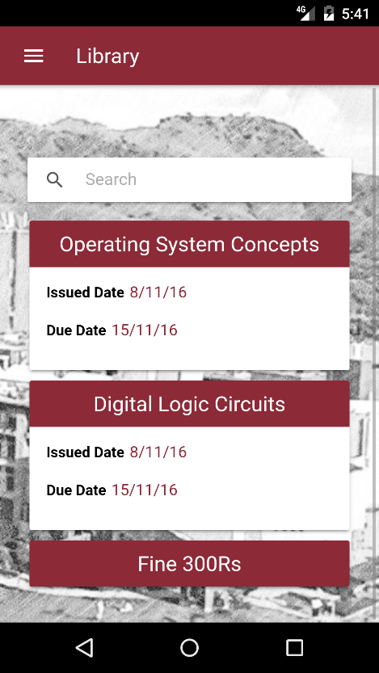

**Desired Outputs**: Searched book displayed.

Issued book displayed

Fine displayed

**Actual Output**: Dummy data displayed

**Negative Scenario**: API Failed

Desired Output: Not Available displayed.

Actual output: Not Available displayed.

TEST CASE STATE: Failed